**Dockerizing Jenkins Pipeline  
Project 1**

**DESCRIPTION**  
Demonstrate the continuous integration and delivery by Dockerizing Jenkins Pipeline.  
  
**Problem Statement Scenario:**   
You are a DevOps consultant in AchiStar Technologies. The company decided to implement DevOps to develop and deliver their products. Since it is an Agile organization, it follows Scrum methodology to develop the projects incrementally. You are working with multiple DevOps Engineers to Dockerize the Jenkins Pipeline. During the sprint planning, you agreed to take the lead on this project and plan on the requirements, system configurations, and track the efficiency. The tasks you are responsible for:   
 • Availability of the application and its versions in the GitHub.  
 ◦ Track their versions every time a code is committed to the repository.  
 • Build the application in Docker and host it in Docker Hub.  
 • Pull the Docker image and run it again.  
The company goal is to deliver the product frequently to the production with high-end quality.  
  
**You must use the following tools:**   
 • Docker – To build the application in a Docker container and push it to Docker Hub  
 • Docker Hub – To store the Docker image  
 • GitHub – To store the application code and track its revisions  
 • Git – To connect and push files from local system to GitHub  
 • Linux (Ubuntu) – As a base operating system to start and execute the project  
 • Jenkins – To automate the deployment process during continuous integration  
  
**Following requirements should be met:** • Document the step-by-step process from the initial installation to the final stage.  
 • Track the versions of the code in the GitHub repository  
 • Availability of the application in the Docker Hub  
 • Track the build status of Jenkins for every increment of the project

Documentation

Environment: Ubuntu in a Vitrualbox on my laptop

**ubuntu2@ubuntu2:~/project-djp$ cat /etc/lsb-release**

DISTRIB_ID=Ubuntu

DISTRIB_RELEASE=20.04

DISTRIB_CODENAME=focal

DISTRIB_DESCRIPTION="Ubuntu 20.04.1 LTS"

**ubuntu2@ubuntu2:~/project-djp$ git --version**

git version 2.25.1

**Setting up project directory, create some files, create repo on github, and push local repo to remote.**

Sequence:

1. mkdir ~/projects/djp #created project directory
2. cd ~/projects/djp
3. git init # Initialize git
4. ls # created the following files and added some content.

file.txt index.html javaprog.java sources

1. git add .
2. git commit -m “Committing project files”
3. git status # To ensure the commit
4. git config --global user.email "[mucharla@gmail.com](mailto:mucharla@gmail.com)"
5. git config --global user.name "smucharla"
6. [https://github.com/smucharla/djp.git](https://github.com/smucharla/project-djp.git) #Created repo on github
7. git remote add origin [https://github.com/smucharla/djp.git](https://github.com/smucharla/project-djp.git) #Added remote origin
8. git push -u origin main #pushed local committed repo to the github via https
9. Verified files existence in github. Confirmed.
10. git branch # To see the branch in use

Please see the screenshots

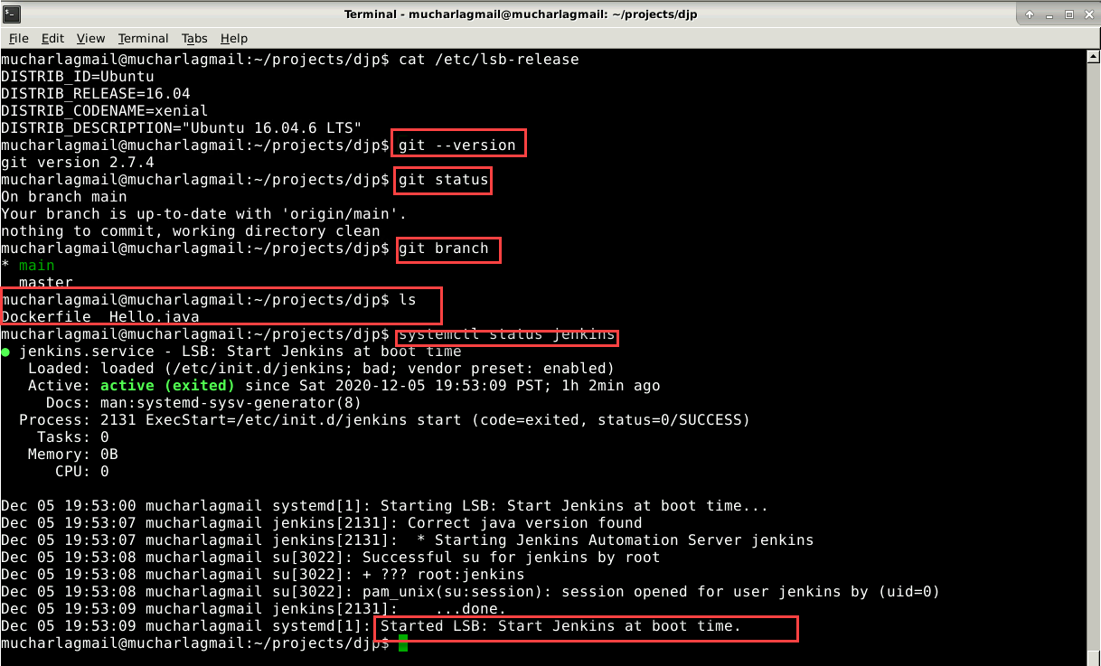

Ubuntu Terminal Window Screenshot #1

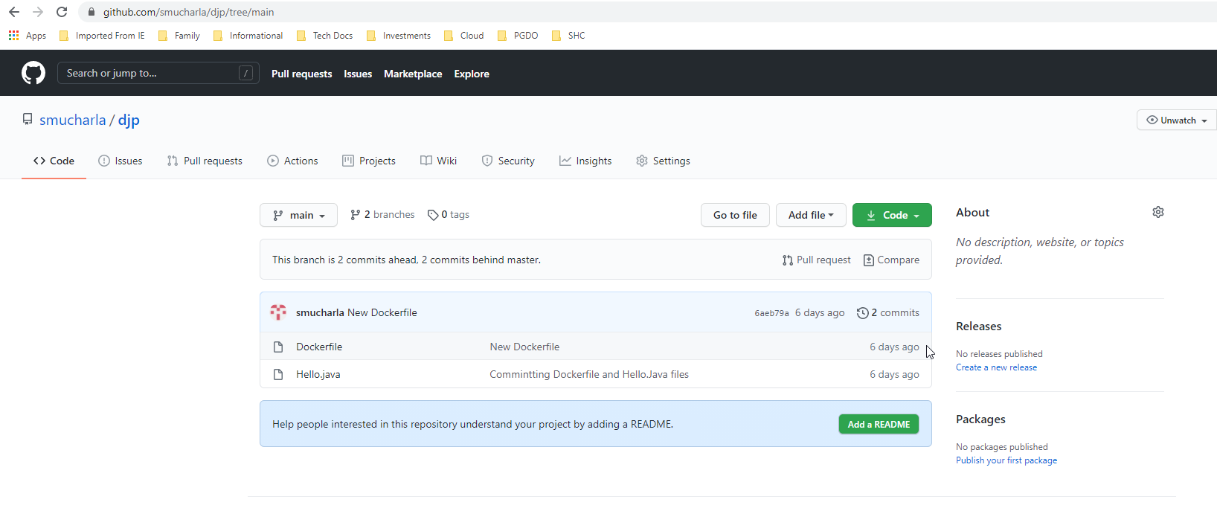

Git repository window screenshot #2

Building docker image and pushing it to the docker hub.

1. Docker build . -t mucharla/myubuntu #for building the docker image
2. Docker push mucharla/myubuntu:latest #for pushing the docker image to the docker hub.

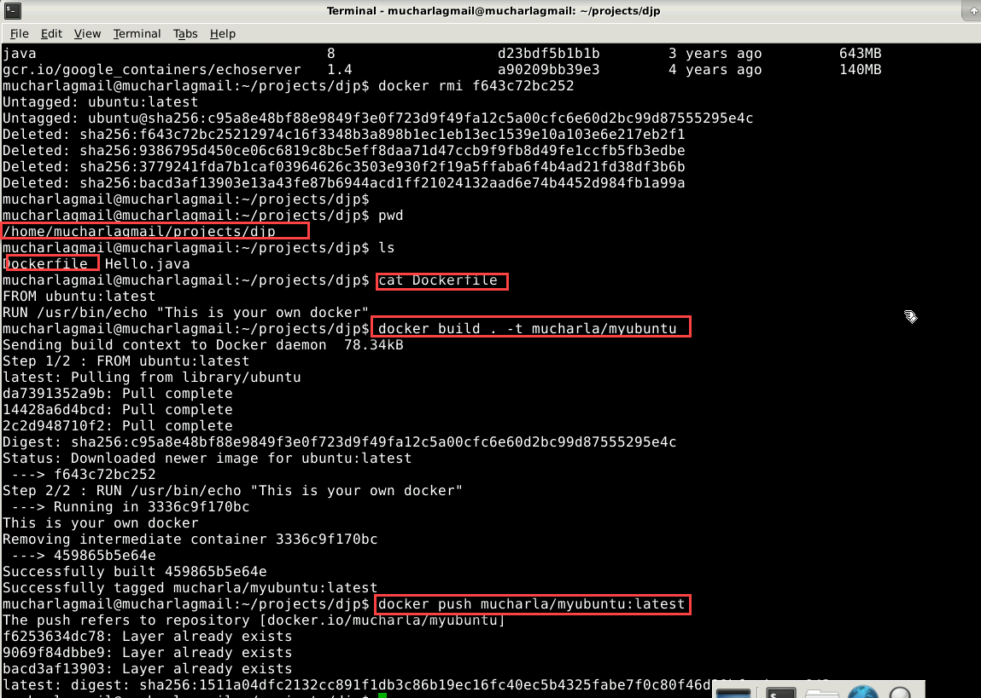

Docker Build and Docker push demonstration Screenshot #3

See the image on hub.docker.com

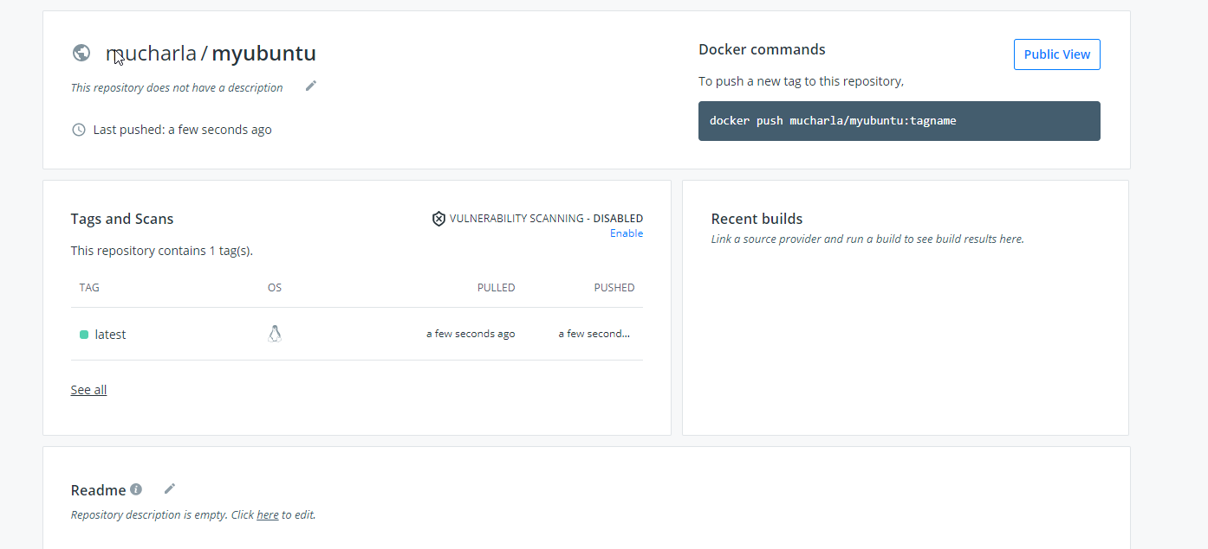

Docker hub Screenshot #4

Creating build job in jenkins

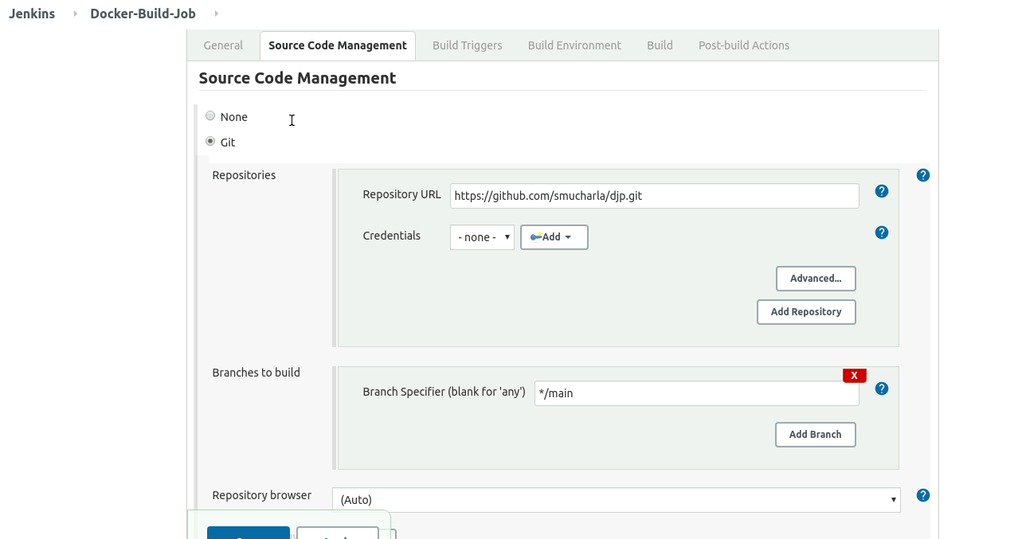

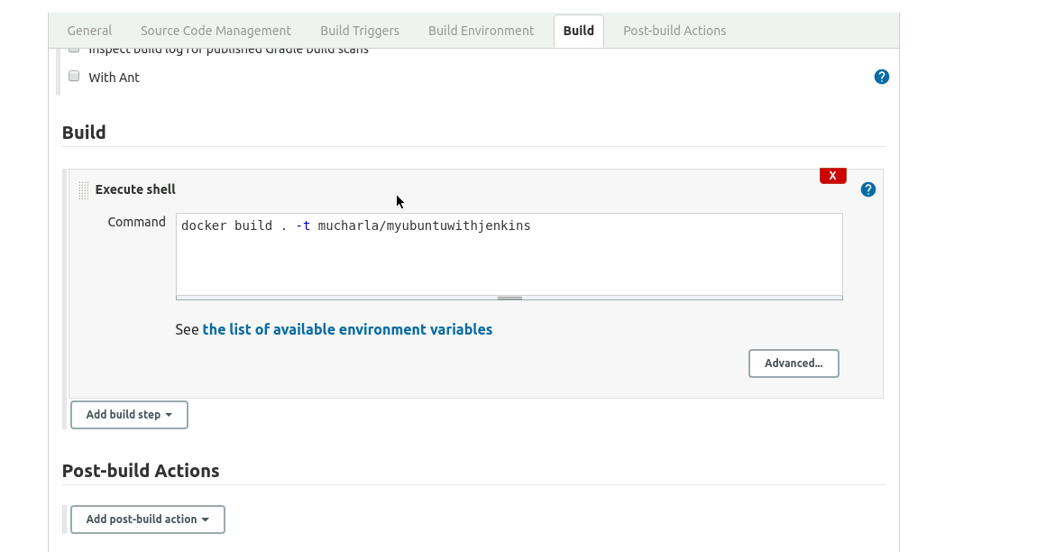

Below screen shows successful completion of build job

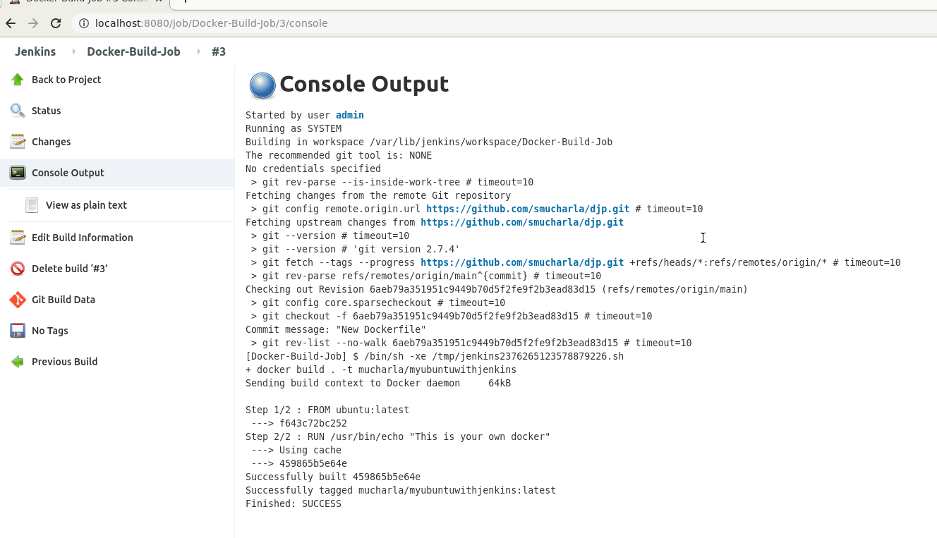

Below screenshot shows the new docker image built.

